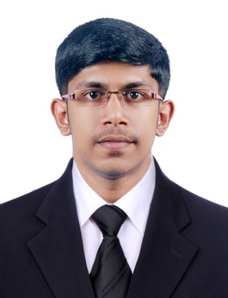
AKHILDAS. A.D

Email: akhildasad1994@gmail.com

Mobile: +91-7561898227

CAREER OBJECTIVE:
To work in a firm with a professional work driven environment where I can utilize and apply my knowledge, skills which would enable me as a fresh graduate to grow while fulfilling organizational goals.

EDUCATIONAL QUALIFICATIONS:
Qualification | Board/University | Institution | Year of completion | Marks(%)/  GPA/CGPA
B-Tech ECE | Calicut university | Setcem  mupliyam | 2016 | 62%
Higher Secondary | State Boards State Board | St.Antony’s  ammadam | 2012 | 65%
SSLC | State secondary Education Examination Board | C.N.N Boy’s  cherpu | 2010 | 68%

Technical Qualification:
- Obtained Post Graduate Diploma in Industrial Automation (PGDIA) from Technocrat Automation Pvt Limited (IAO Accredited), Chennai. With 11 months hands on practical experience in Industrial Automation Tools specializing in PLC, DCS, SCADA and VFD.

Technical Skills:
- PLC (Programmable Logic Controllers) & DCS (Distributed Control System) - Programming languages such as LD(Ladder Diagram) & FBD (Functional Block Diagram)
- Hands on Practical exposure in brands as Siemens, AB (Allen Bradley), ABB (Asea Brown Boveri), Honeywell, Rockwell, Schneider, GE-Fanuc, Keyence, Omron, Messung, Mitsubishi, and Delta
- SCADA (Supervisory Control & Data Acquisition) – Screen designing, PC & PLC interface, Data collection & storage
- HMI (Human Machine Interface) - Screen designing, PLC interface, DCS interface
- PAC (Programmable Automation Controller) – X, Y axis Robotic Control using Servo motors & drives
- VFD (Variable Frequency Drive) – Commissioning and Troubleshooting
- Pneumatics & Field Instruments ( Control Valve, Sensors, Level Transmitters, Flow Transmitters, Temperature Transmitters, Pressure Switches)
- Interfacing between PLC & GSM modem to communicate with mobile device
- Knowledge in Panel wiring
- Knowledge in PID(Proportional Integral Derivative)
- Troubleshooting – PLC & DCS programming
- Control Panel (Power wiring & Control wiring)

ACHIEVEMENTS / CO-CURRICULAR ACTIVITIES / EXTRA CURRICULAR ACTIVITIES:
- Kabaddi state Zonal team player-2010.
- District, Revenue district won first prize for kabaddi.
- Sports captain-2010.

INPLANT Training / INDUSTRIAL VISIT:
- Participated in TECHKRITI 2015 IIT KANPUR organized by Spark lab Engineering System.

Computer Skills / KNowledge:
- Technical areas: Knowledge in PIC microcontrollers, simulation packages like VHDL Lab
- Microsoft office word, Microsoft office excel, Microsoft office power point

Personal profile:

Father’s Name : Devadas .A.S
Date of Birth : 29-07-1994
Gender : Male
Passport Number & Validity :
Language Known : English, Malayalam & Tamil.
Hobbies : Swimming, Drawing, Playing kabaddi
Address : Ainikunnan(H), P.o Avinissery, Anakkallu,
Thrissur district, Pin-680306, Kerala, India

DECLARATION:
I hereby declare that the above particulars furnished by me are true to the best of my knowledge and belief.

Date:
Place: AKHILDAS .A.D

